**PROGRAM 5: AIRLINE FLIGHT DATABASE**

**Consider the following database that keeps track of airline flight information:**

**FLIGHTS(flno: integer, from: string, to: string, distance: integer, departs: time, arrives: time, price: integer)**

**AIRCRAFT(aid: integer, aname: string, cruisingrange: integer)**

**CERTIFIED(eid: integer, aid: integer)**

**EMPLOYEES(eid: integer, ename: string, salary: integer)**

**Note that the Employees relation describes pilots and other kinds of employees as well; Every pilot is certified for some aircraft, and only pilots are certified to fly.**

**rite each of the following queries in SQL.**

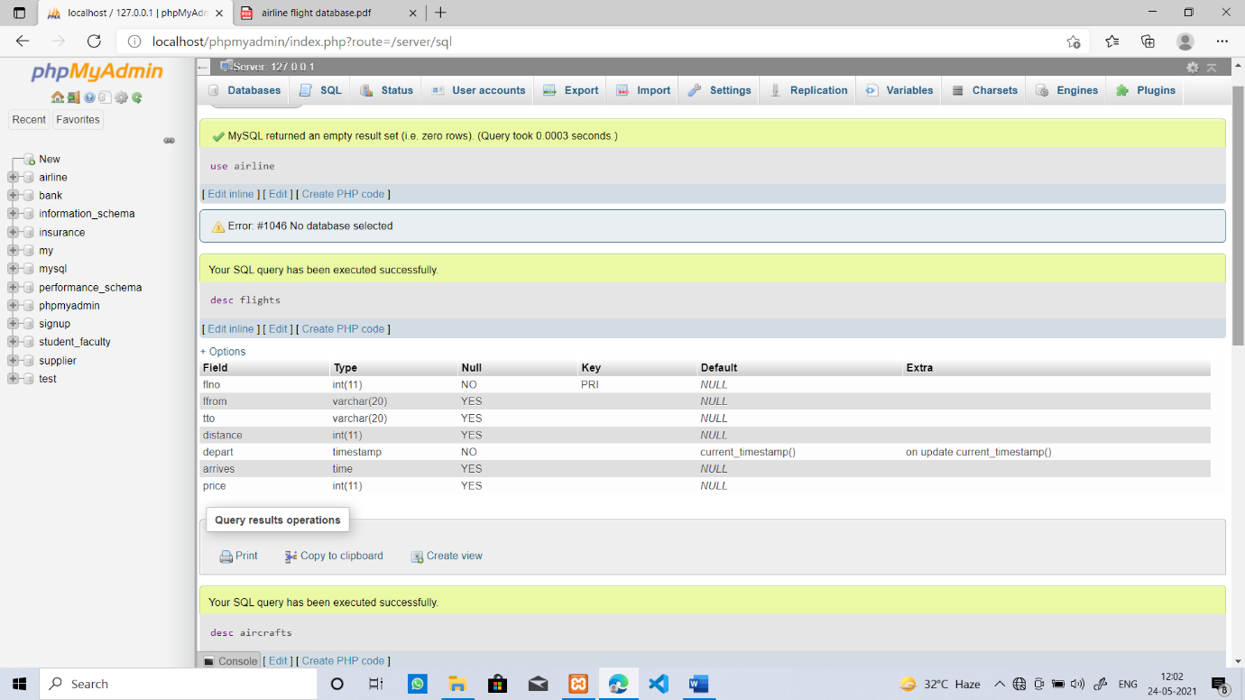

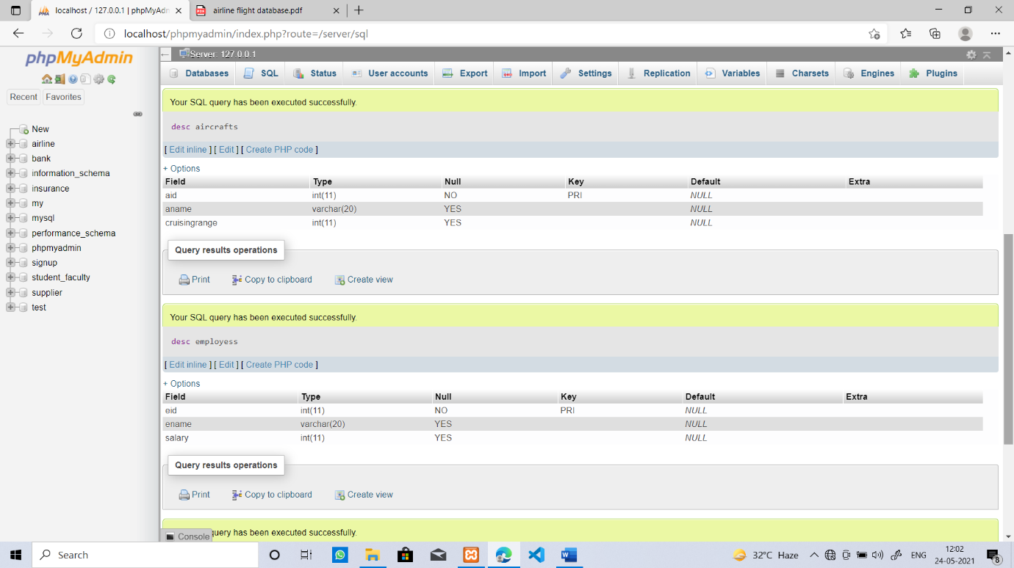

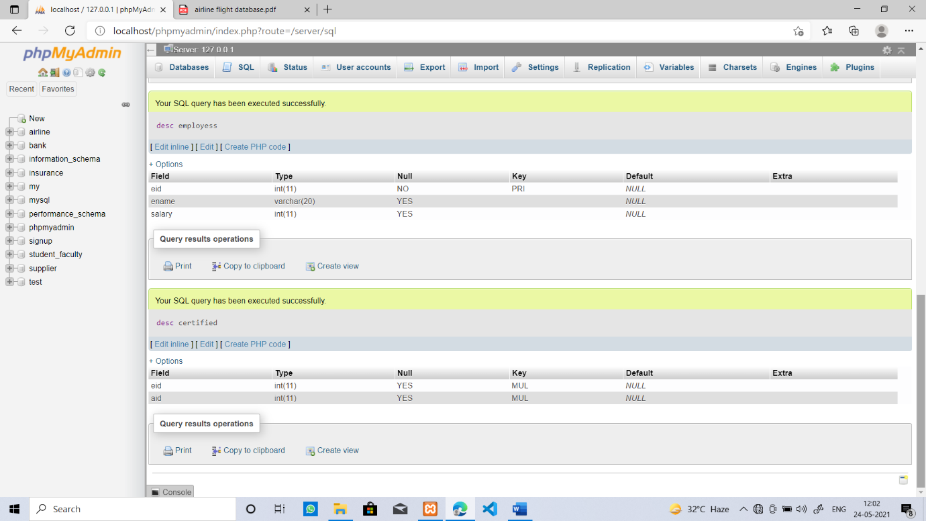

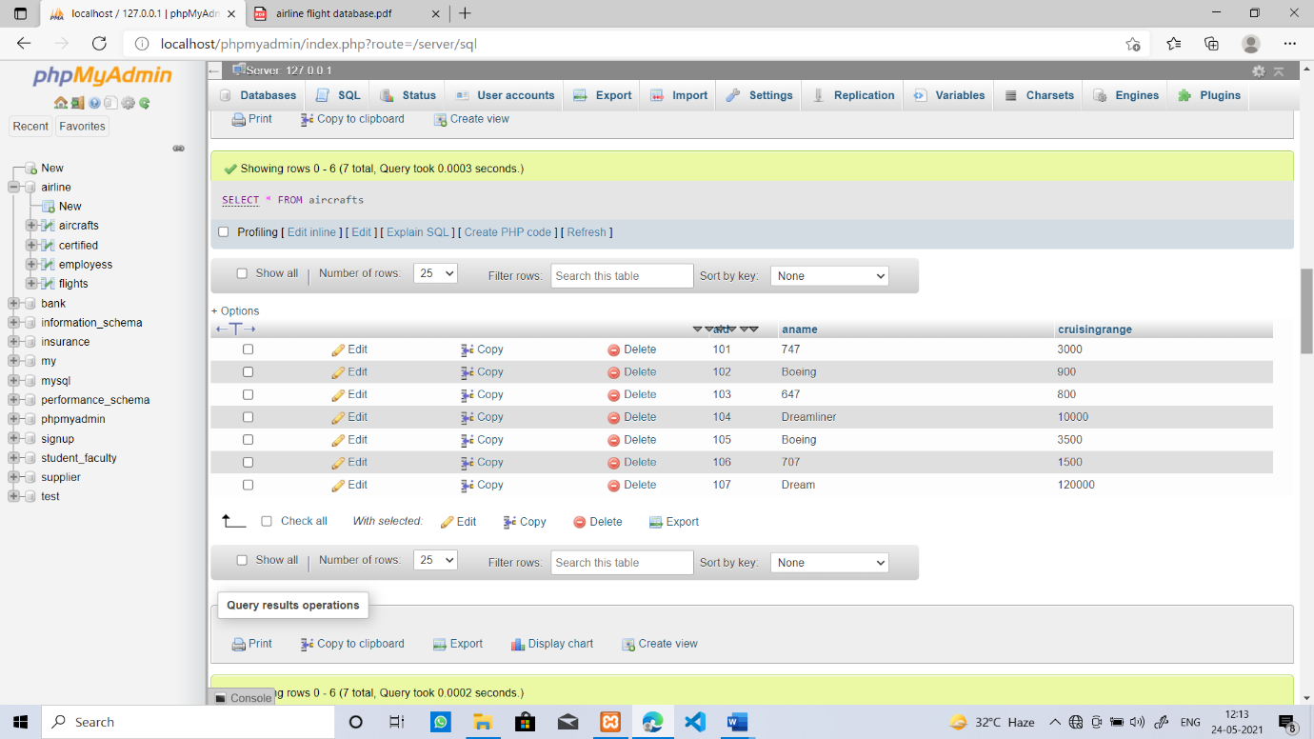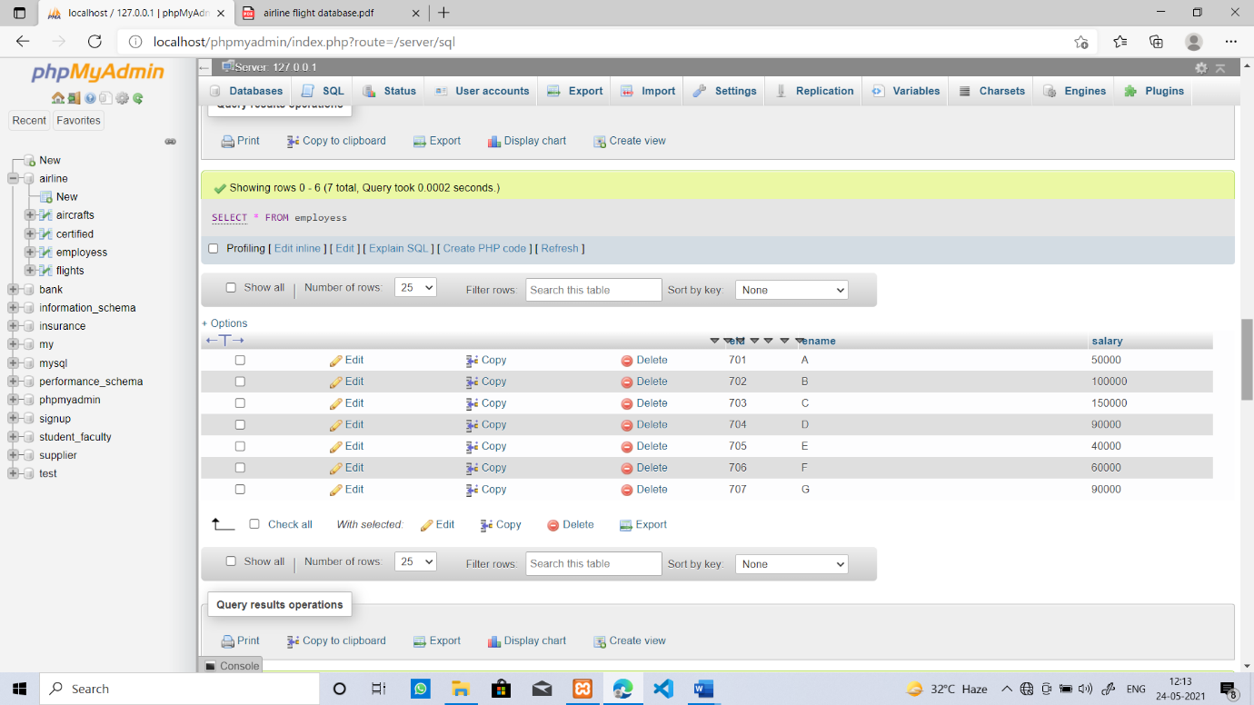

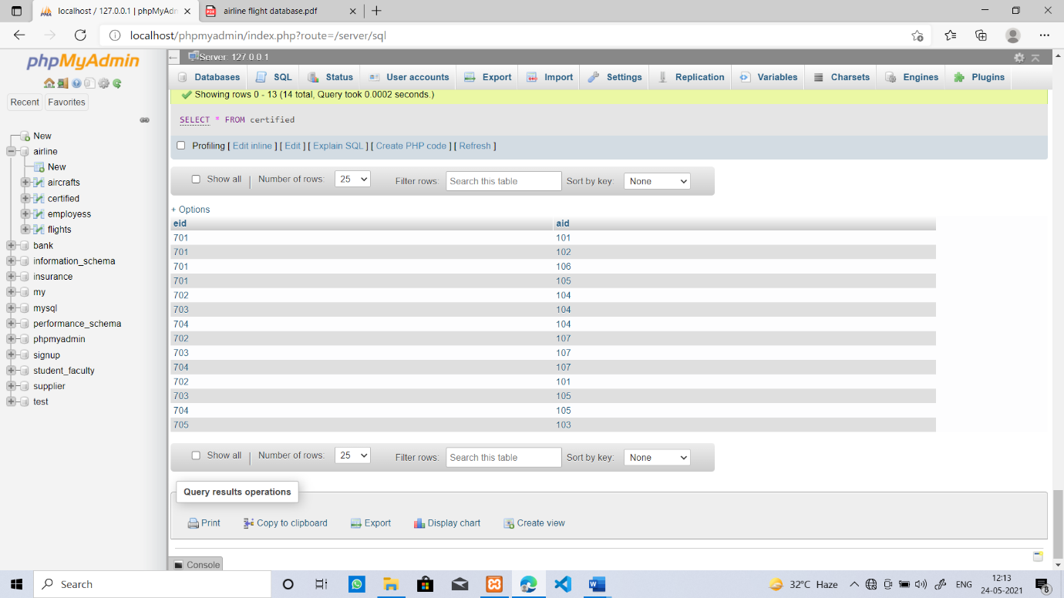

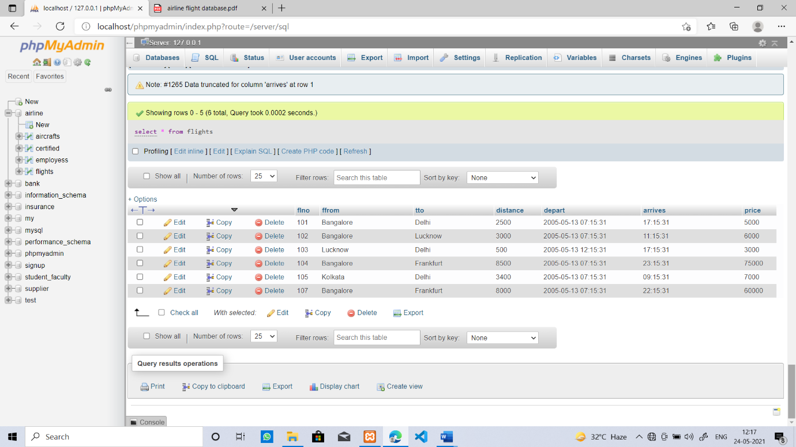

1. **Find the names of aircraft such that all pilots certified to operate them have salaries more than Rs.80,000.**

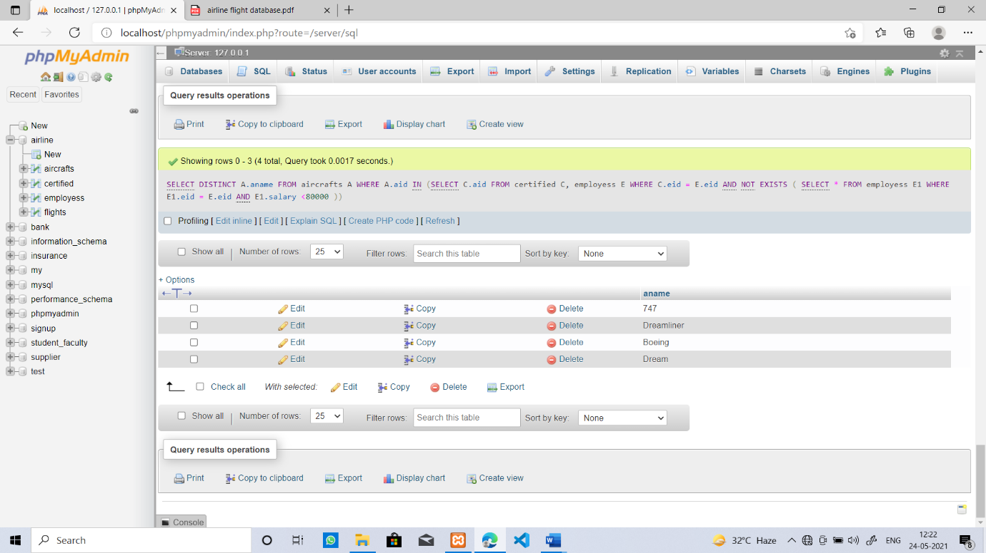

1. **For each pilot who is certified for more than three aircrafts, find the eid and the maximum cruising range of the aircraft for which she or he is certified.**

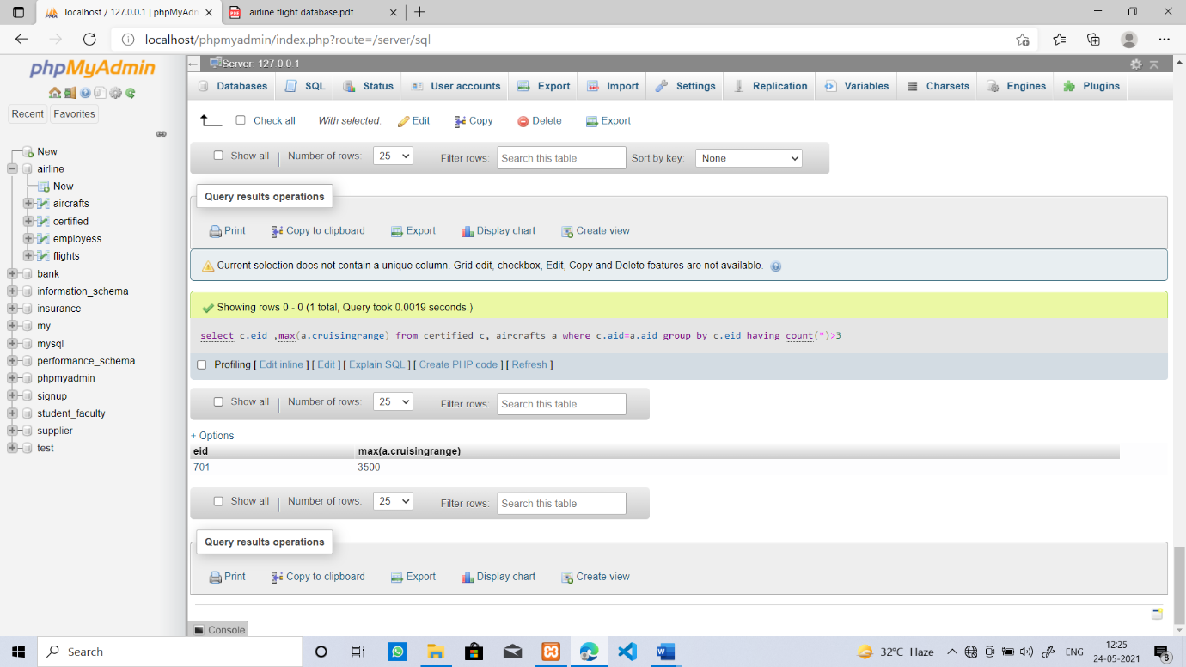

1. **Find the names of pilots whose salary is less than the price of the cheapest route from Bangalore to Frankfurt.**

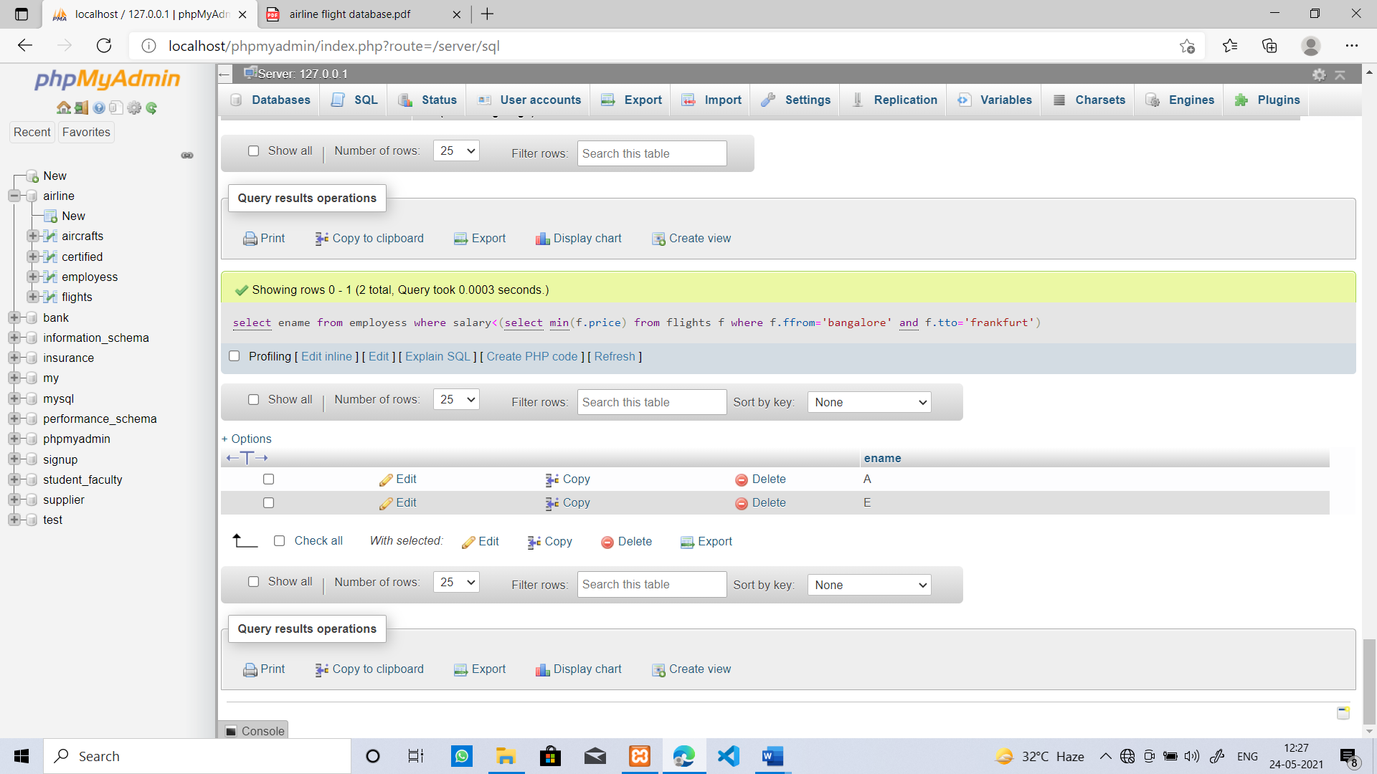

**iv) For all aircraft with cruising range over 1000 Kms, find the name of the aircraft and the average salary of all pilots certified for this aircraft.**

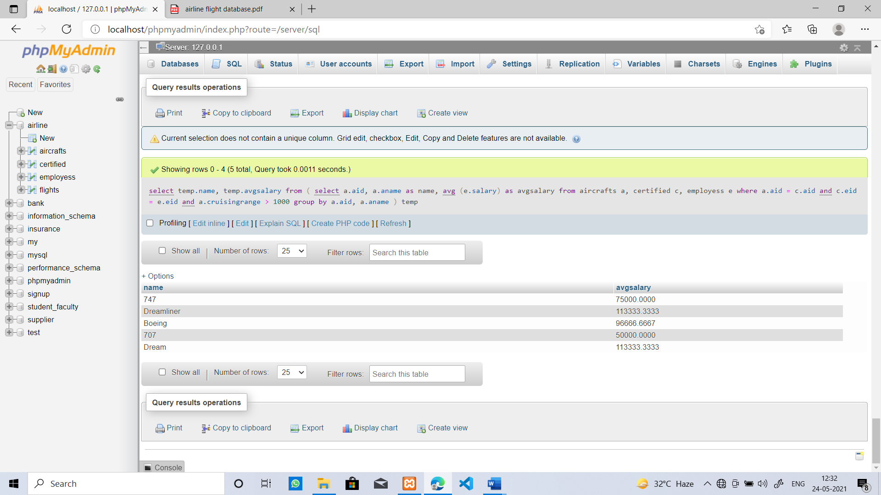

1. **Find the names of pilots certified for some Boeing aircraft.**

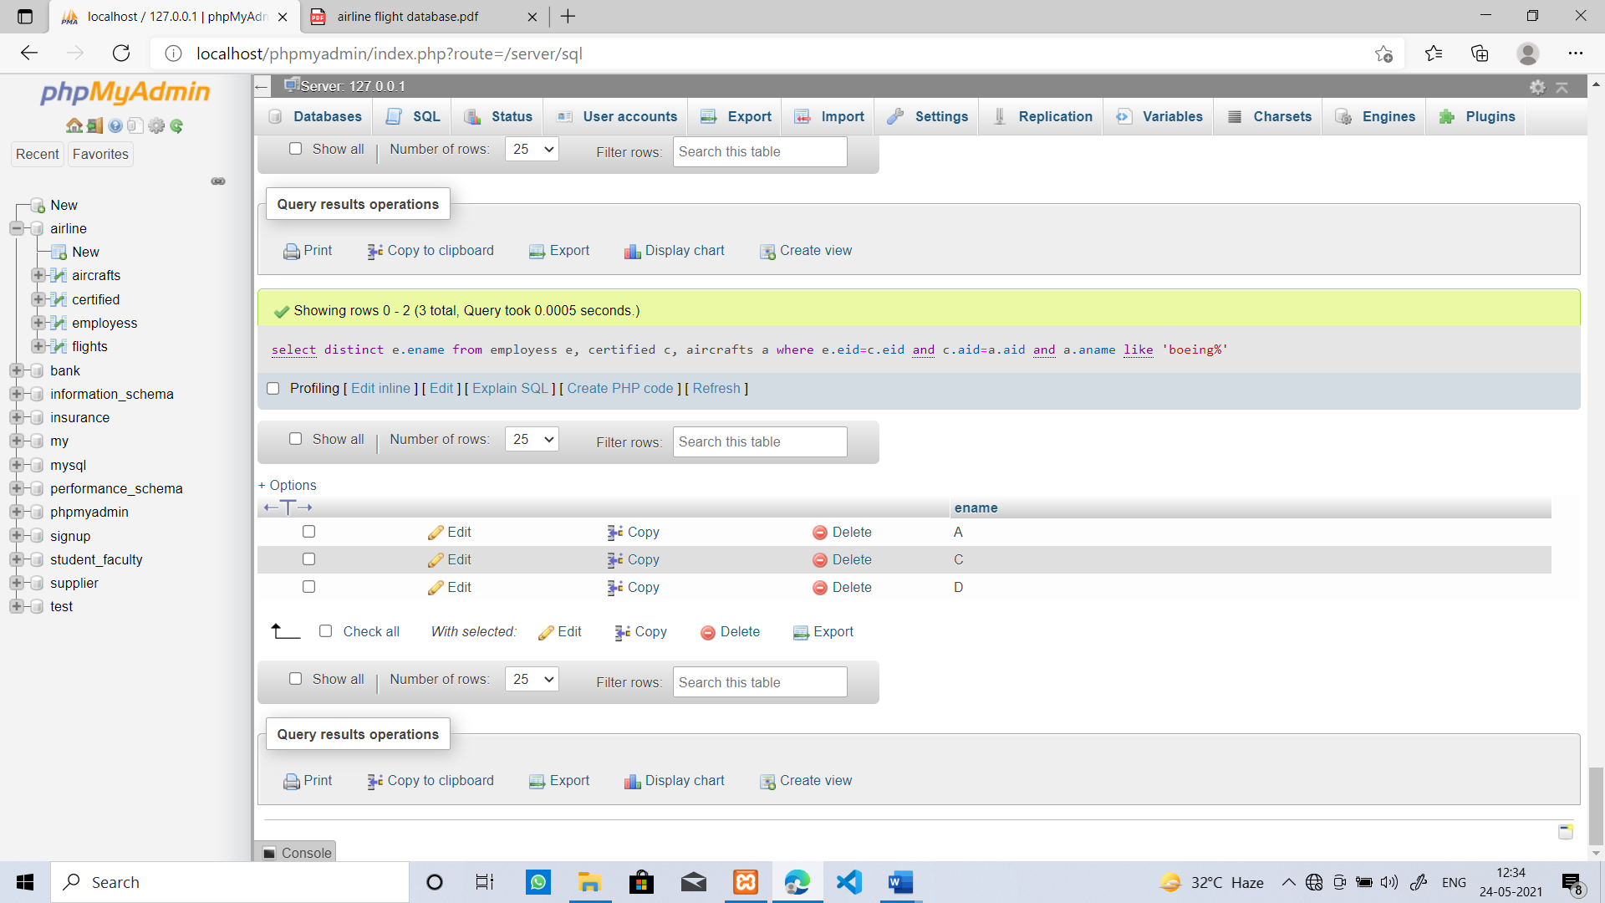

1. **Find the aids of all aircraft that can be used on routes from Bangalore to Frankfurt.**

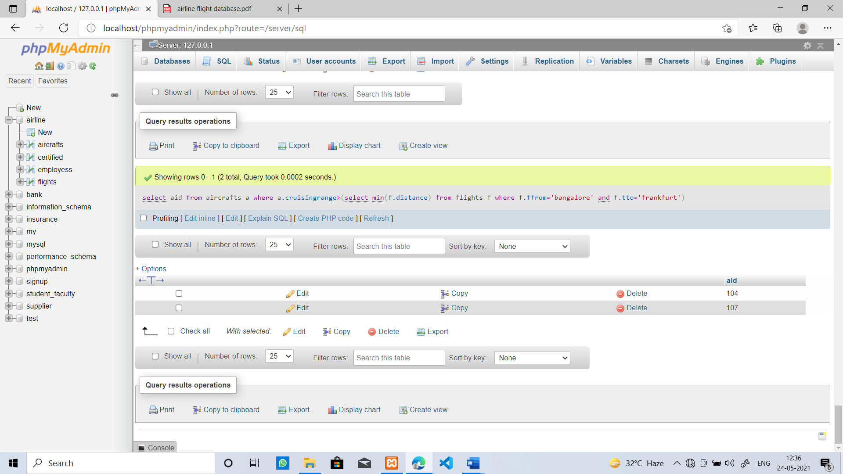

1. **A customer wants to travel from Bangalore to Delhi with no more than two changes of flight. List the choice of departure times from Bangalore if the customer wants to arrive in Delhi by 6 p.m.**

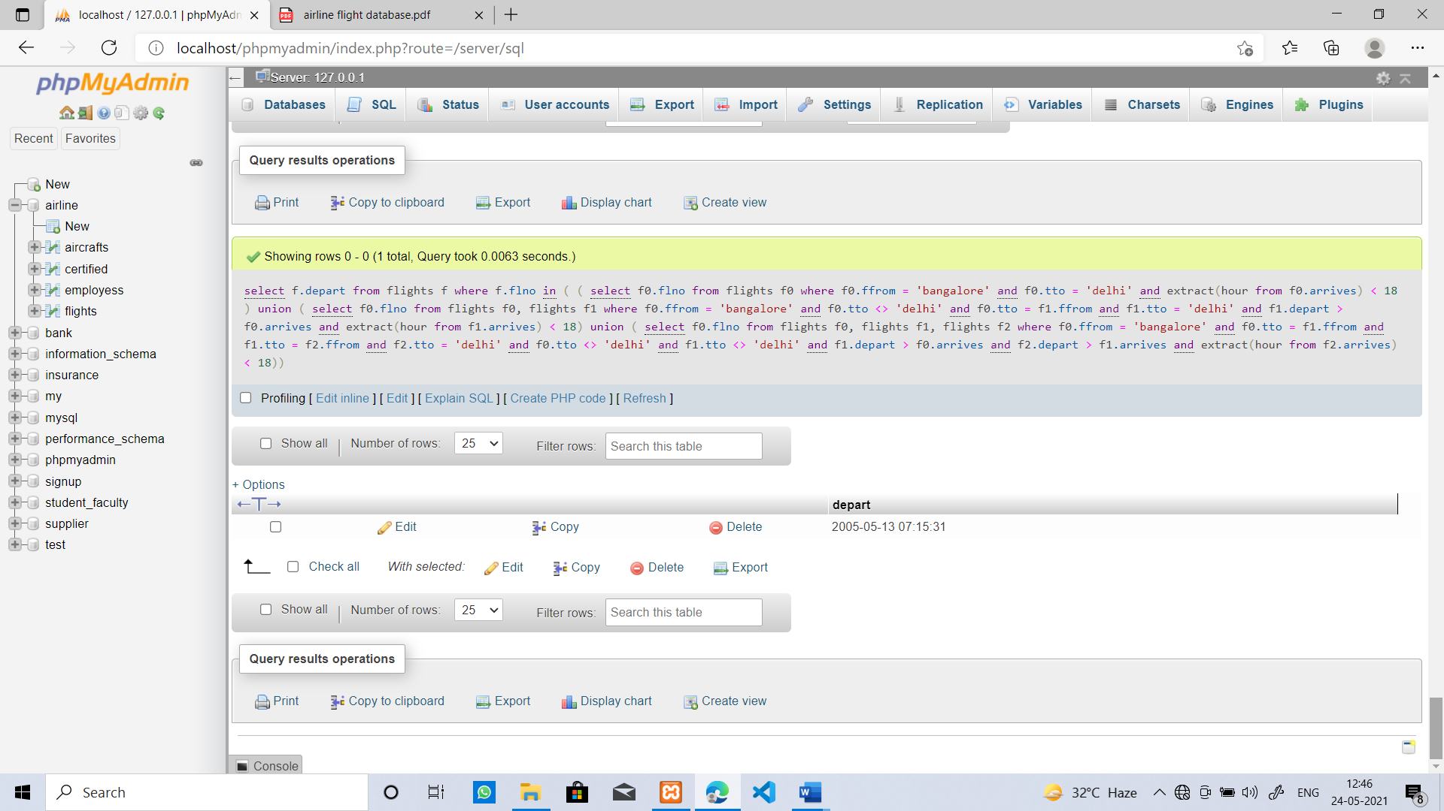

1. **Print the name and salary of every non-pilot whose salary is more than the average salary for pilots.**

